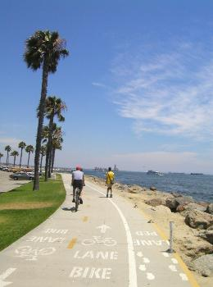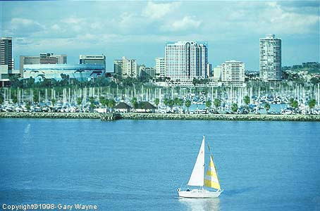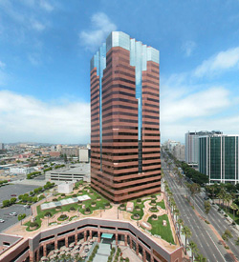

The 14th Reconfigurable Architectures Workshop (RAW 2007) will be held in Long Beach in March 2007. RAW 2007 is associated with the 21st Annual International Parallel & Distributed Processing Symposium (IPDPS 2007) and is sponsored by the IEEE Computers Society's Technical Committee on Parallel Processing. RAW 2007 is one of the major meetings for researchers to present ideas, results, and on-going research on both theoretical and practical advances in Reconfigurable Computing.

Run-Time Reconfiguration & Adaptive Computing: Architectures, Algorithms, Technologies
Run-Time and Dynamic Reconfiguration are characterized by the ability of underlying hardware architectures or devices to rapidly alter (on the fly) the functionalities of its components and the interconnection between them to suit the problem. Key to this ability is reconfiguration handling and speed. Though theoretical models and algorithms for them have established reconfiguration as a very powerful computing paradigm, practical considerations make these models difficult to realize. On the other hand, commercially available devices (such as FPGAs and new coarse-/multi-grain devices) appear to have more room for exploiting run-time reconfiguration (RTR). An appropriate mix of the theoretical foundations of dynamic reconfiguration, and practical considerations, including architectures, technologies and tools supporting RTR is essential to fully reveal and exploit the possibilities created by this powerful computing paradigm. RAW 2007 aims to provide a forum for creative and productive interaction between all these disciplines.

Special Focus – Coarse Grain Reconfigurable
Reconfigurable Architectures Workshop 2007 wants to emphasize the importance of coarse grain related topics including architectures, models, applications, algorithms and tools. Therefore we highly encourage researchers to present their novel approaches. Accepted papers will be presented in special sessions.

Topics of Interest
Authors are invited to submit manuscripts of original unpublished research in all areas of dynamic and run-time reconfiguration (foundations, algorithms, hardware architectures, devices, systems-on-chip (SoC), technologies, software tools, and applications). The topics of interest include, but are not limited to:

Models & Architectures  - Theoretical Interconnect  and Computation Models  - RTR Models and Systems  - RTR Hardware Architectures  - Optical Interconnect Models  - Simulation and Prototyping  - Bounds and Complexity Issues | Algorithms & Applications  - Algorithmic Techniques  - Mapping Parallel Algorithms  - Distributed Systems & Networks  - Fault Tolerance Issues  - Wireless and Mobile Systems  - Automotive Applications  - Infotainment & Multimedia  - Biology Inspired Applications | Design, Technologies & Tools  - Configurable Systems-on-Chip  - Energy Efficiency Issues  - Devices and Circuits  - Reconfiguration Techniques  - High Level Design Methods  - System Support  - Adaptive Runtime Systems  - Organic Computing

Submission Guidelines:
Authors should submit and register their paper through our web-interface at: http://raw.itiv.uni-karlsruhe.de by October 15, 2006. (T web interface will be accessible after Sept. 1st, 2006)

All manuscripts will be reviewed by at least three members of the program committee. Submissions should be a complete manuscript (not to exceed 8 pages of single spaced text, including figures and tables) or, in special cases, may be a summary of relevant work. Submissions should be in pdf-format (preferred), or alternatively in Postscript (level 2) format. Authors should make sure that the submission can be viewed using ghostscript and will print on standard letter size paper (8.5" x 11").
IEEE CS Press will publish the IPDPS symposium and workshop abstracts as a printed volume. The complete symposium and workshop proceedings will also be published by IEEE CS Press as a CD-ROM disk.

Important Dates:

Manuscript due: October 15, 2006
Notification of acceptance: November 15, 2006

Organization:

Workshop Chair: Serge Vernalde, IMEC, Belgium
(vernalde@imec.be)
Program Chair: Jürgen Becker, Universität Karlsruhe (TH), Germany
(becker@itiv.uni-karlsruhe.de)
Steering Chair: Viktor K. Prasanna, University of Southern California, USA (prasanna@ganges.usc.edu)
Publicity Chair (USA): Ramachandran Vaidyanathan, Louisiana State University, USA
(vaidy@ece.lsu.edu)
Publicity Chair (Europe, Asia): Reiner Hartenstein, Kaiserslautern University of Technology, Germany
(reiner@hartenstein.de)

Program Committee:

Jeffrey Arnold | Adaptive Silicon Inc., | Philip Leong | Chinese University of Hong Kong
Mauricio Ayala | Universidade de Brasilia | Marnane Liam | University College
Sergio Bampi | Universidade Federal do Rio Grande | Wayne Luk | Imperial College
Juergen Becker | Universitaet Karlsruhe (TH) | Juergen Luka | DaimlerChrysler AG
Pascal Benoit | LIRMM | Patrick Lysaght | Xilinx
Mladen Berekovic | IMEC | John McHenry | National Security Agency
Neil Bergmann | University of Queensland | Martin Middendorf | Universitäty of Leipzig
Don Bouldin | University of Tennessee | Amar Mukherjee | University of Central Florida
Elaheh Bozorgzadeh | University of California | Koji Nakano | Hiroshima University
Gordon Brebner | Xilinx | Ranjani Parthasarathi | Anna University, Chennai
Thomas Buechner | IBM | Marco Platzner | Universität Paderborn
Fabio Campi | Università di Bologna | Cameron Patterson | Virginia Tech
Luigi Carro | Universidade Federal do Rio Grande | Thilo Pionteck | Universität Lübeck
Peter Y. K. Cheung | Imperial College, London | Joachim Pistorius | Altera
Andreas Dandalis | Philips | Bernard Pottier | Université de Bretagne Occidentale
Oliver Diessel | University of New South Wales | Franz Rammig | Universität Paderborn
Adam Donlin | Xilinx | Ricardo Reis | Universidade Federal do Rio Grande
Pedro C. Diniz | University of Southern California | Marco Santambrogio | Politecnico di Milano
Gilbert Edelin | Thales Research & Technology | Hartmut Schmeck | Universität Karlsruhe (TH)
Hossam ElGindy | University of New South Wales | Sakir Sezer | Queen's University
Manfred Glesner | Darmstadt University of Technology | Gerard Smit | University of Twente
Steve Guccione | Cmpware, Inc. | Srinivas Katkoori | Univ of South Florida
Masanori Hariyama | Tohoku University | V. Sridhar | Satyam Computer Services Ltd.
Reiner Hartenstein | University of Kaiserslautern | Juergen Teich | Friedrich-Alexander-Universitaet Erlangen
Ulrich Heinkel | Lucent Technologies | Lionel Torres | LIRMM, Montpellier
Andreas Herkersdorf | Institute for Integrated Systems | Jim Tørresen | University of Oslo
Christian Hochberger | Dresden University of Technology | Jerry L. Trahan | Louisiana State University
Thomas Hollstein | Darmstadt University of Technology | Ramachandran Vaidyanathan | Louisiana State University
Michael Hübner | Universität Karlsruhe | Carlos Valderrama | University Mons
Mark Jones | Virginia Tech | Milan Vasilko | Bournemouth University
Udo Kebschull | Universität Leipzig | Stamatis Vassiliadis | Delft University of Technology
Andreas Koch | Technische Universität Braunschweig | Brian Veale | University of Oklahoma
Rainer Kress | Infineon Technologies | Martin Vorbach | PACT Informationstechnologie
Helena Krupnova | ST Microelectronics | Klaus Waldschmidt | Universität Frankfurt
Vera Lauer | DaimlerChrysler AG | Norbert Wehn | University of Kaiserslautern
Rudy Lauwereins | IMEC, Leuven

