EE 3755 Verilog Homework 1 Due: Oct 20, 2010

Estimated time to solve:
Prob.1 30 minutes.
Prob.2 30 minutes.
Prob.3 30 minutes.
Prob.4 30 minutes.
Preparing text files 1 hour.
Total 3 hours.
How to submit?
// No hard copy.
// Name your code file as hw1.v
// Name your script file as hw1.txt
// Leave your code file(hw1.v) and
// your script file(hw1.txt) on the class account.

Finish your code file(hw1,v) first, then do the followings:

Use “script hw1.txt “ command // To take a snap shot of your code. If you don’t know
// script command, look at the handout.
Use “cat hw1.v” command // To display contents of your code.
Use “ncverilog hw1.v” // To run your code.
then stop the script.

Example) SUN>script hw1.txt
SUN>cat hw1.v
SUN>ncverilog hw1.v
SUN> ( stop script by pressing CTRL-D)

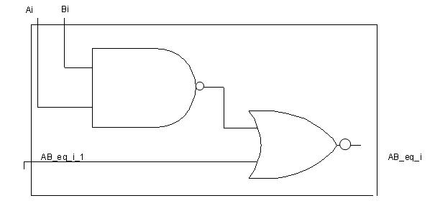

Fig.1 One_Bit_NAND Slice.
(one_NAND gate,one_NOR gate , three inputs and one output)
//Circuit for the Problem 1.

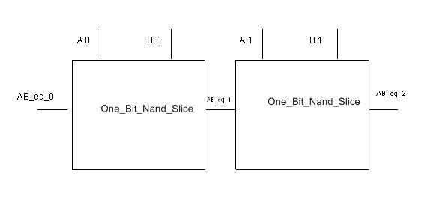

Fig.2 Two One_Bit_Nand Slices( cascaded for the problem 3.)

Fig.3 One Bit Comparator Slice.( Cascadable for the problem 4)
This one has 4 one-bit- inputs(Ai, Bi, AeqBin, and AgtBin)
and 2 one-bit-outputs(AeqB and AgtB).
AeqB = 1 when (Ai=Bi and AeqBin =1).
AgtB = 1 when Ai > Bi or (Ai = Bi and AgtBin = 1).

Problem 1: Complete module one_bit_Nand_slice_ex (in the homework template) so that it is an explicit structural description of the circuit illustrated at Fig.1. Remember that this module
only handles one bit of A and B.

Problem 2: Complete module one_bit_Nand_slice_im so that it is an implicit structural description of the circuit illustrated at Fig.1. Remember that this module only handles one bit of A and B.

Problem 3: Complete module two_one_bit_Nand_slices illustrated at Fig.2 by using two one_bit_Nand_slice_im modules and explicit structural descriptions.
Problem 4: Module three_bit_comparator is used to compare two three-bit numbers.
It has two three-bit inputs( a and b), and two one-bit outputs( AeqB and AgtB). The code for the one- bit- comparator is given.

Complete the module three_bit_comparator by using three one-bit-comparators.
For example) if three-bit inputs a=111, b=111 then AeqB is 1 and AgtB is 0.
if three-bit inputs a=110, b=100 then AeqB is 0 and AgtB is 1.

/// LSU EE 3755 Fall 2010 Verilog_Homework 1- Code template.
/// Instructions:
//
// Copy this to a file( name it hw1.v) and save on your class account.
// Use this file for your solution.
//Your entire solution should be on this file.
// Do not rename the modules in this file and be sure to use the filename given above.
////////////////////////////////////////////////////////////////////////////////
/// Problem 0
module hello();
initial begin
//display your name and class account.
// Write your code here.
// for example
// if your name is "Clark Kent" and class account is ee375501
// the exact answer will be:
$display("ee375501 Clark Kent\n"); //simply change the account number and name.
end
endmodule
////////////////////////////////////////////////////////////////////////////////
/// Problem 1
module one_bit_Nand_slice_ex(ab_eq_1,ab_eq_0,a,b);
input a, b,ab_eq_0;
output ab_eq_1;
wire and_ab;
// your solution goes here

endmodule
////////////////////////////////////////////////////////////////////////////////
/// Problem 2
module one_bit_Nand_slice_im(ab_eq_1,ab_eq_0,a,b);
input a, b,ab_eq_0;
output ab_eq_1;
// your solution goes here

endmodule
////////////////////////////////////////////////////////////////////////////////
/// Problem 3
module two_one_bit_Nand_slices (ab_eq_2,a,b,ab_eq_0);
input [1:0] a, b;
input ab_eq_0;
output ab_eq_2;
wire ab_eq_1;
// your solution goes here
// less than 3 lines.
endmodule
////////////////////////////////////////////////////////////////////////////////

////////////////////////////////////////////////////////////////////////////////
//// Problem 4
module one_bit_comparator(AeqB, AgtB, a, b, AeqBin, AgtBin);
input a, b,AeqBin,AgtBin;
output AeqB,AgtB;
reg AeqB,AgtB;
always begin
if(a == b & AeqBin ==1) AeqB = 1; else AeqB = 0;

if(a > b | (a ==b & AgtBin ==1)) AgtB = 1; else AgtB =0;
#1;
end

endmodule
//complete this module
module three_bit_comparator(AeqB, AgtB, a, b);
input [2:0] a, b;
output AeqB,AgtB;
wire AeqB1,AgtB1,AeqB2,AgtB2;
//Your solution goes here
//less than 4 lines

endmodule

////////////////////////////////////////////////////////////////////////////////
/// Test Bench
/// Do not modify test bench
///You don’t have to understand this code.
module test();
wire aeqb,agtb;
reg [2:0] a, b;
integer i;
three_bit_comparator com1(aeqb,agtb,a,b);
initial begin
for(i=0; i<=63; i=i+1) begin
a = i[2:0];
b = i[5:3];

#10;
$display("a = %d,b=%d,eq=%d,gt=%d\n",a,b,aeqb,agtb);
end
$display("Tests completed.");

end

endmodule

