EE 3755 Homework 1 Due: Oct. 20.

Estimated time to solve:
Prob.1 30 minutes.
Prob.2 30 minutes.
Prob.3 1 hours.
Prob.4 1 hours.
Total 3 hours.
How to submit?
// No hard copy.
// Name your program file as hw1.v
// Name your script file as hw1.txt
// Leave your program file(hw1.v) and
// your script file(hw1.txt) on the class account.

Finish your program file(hw1,v) first, then do the followings:

Use “script hw1.txt “ command // To take a snap shot of your program. If you don’t know
// script command, look at the handout.
Use “cat hw1.v” command // To display contents of your program.
Use “ncverilog hw1.v” //To run your program.
then stop the script.

Example) SUN>script hw1.txt
SUN>cat hw1.v
SUN>ncverilog hw1.v
SUN> ( stop script by pressing CTRL-D)

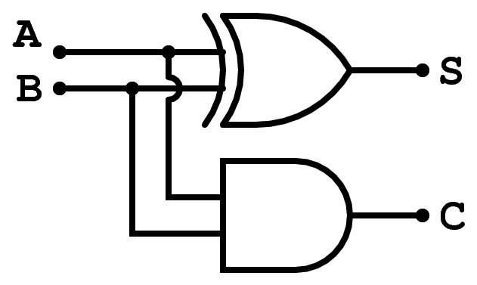
Fig.1 Half-Adder.
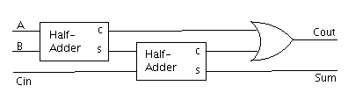
Fig.2 Full Adder by using two half-adders.

Copy the homework template into your account and name it hw1.v.
Simulate the welcome module in the homework template.
#
Problem 1: Complete module half_adder_ex (in the homework template) so that it is an explicit
structural description of the half adder illustrated at Fig.1. Remember that this module
only handles one bit of A and B.

Problem 2: Complete module half_adder_im so that it is an implicit structural description of the half adder illustrated at Fig.1. Remember that this module only handles one bit of A and B.

Problem 3: Complete module full_adder illustrated at Fig.2 by using two half_adder_im modules and explicit structural descriptions.
Problem 4: Module two_bit_adder is used to add two two-bit numbers. It has two two-bit inputs, a and b, and two-bit output s and one-bit output c.
Complete the module. The module must instantiate two copies of
full_adder from the problem above.
For example) if two-bit input a=11, b=11 then s = 10 and c = 1.

///
/// LSU EE 3755 Fall 2006 Verilog_Homework 1- Program template.
/// Instructions:
//
// Copy this to a file( name it hw1.v) and
//save on your class account.
//Use this file for your solution.
//Your entire solution should be on this file.
// Do not rename the modules in this file and be sure to use the filename given above.

////////////////////////////////////////////////////////////////////////////////
/// Problem 0
module hello();
initial begin
//display your name and class account.
// Write your code here.
// for example
// if your name is "Clark Kent" and class account is ee375501
// the exact answer will be:
$display("ee375501 Clark Kent\n");//simply change the account number and name.
end
endmodule
////////////////////////////////////////////////////////////////////////////////
/// Problem 1
module half_adder_ex(s,c,a,b);
input a, b;
output s,c;
// your solution goes here
//

endmodule
////////////////////////////////////////////////////////////////////////////////
/// Problem 2
module half_adder_im(s,c,a,b);
input a, b;
output s,c;
// your solution goes here

endmodule
////////////////////////////////////////////////////////////////////////////////
/// Problem 3
module full_adder(s,c,a,b,c1);
input a, b,c1;
output s,c;
wire s_ha1, c_ha1, c_ha2;
// your solution goes here

endmodule
/// Problem 4
module two_bit_adder(s,c,a,b,);
input [1:0] a, b;
output [1:0] s;
output c;
wire c_ha1;
// your solution goes here

endmodule

////////////////////////////////////////////////////////////////////////////////
/// Test Bench
/// Do not modify test bench
module test();
wire [2:0] sum1;
reg [2:0] shadow_sum;
reg [1:0] a, b;
integer i;
two_bit_adder adder1(sum1[1:0],sum1[2],a,b);

task check_sum;
input [2:0] s;
input [79:0] name;

if( s != shadow_sum ) begin
$display("Wrong sum in %s: %d + %d = %d != %d\n",
name, a, b, shadow_sum, s);
$stop;
end

endtask

initial begin

for(i=0; i<=15; i=i+1) begin
a = i[1:0];
b = i[3:2];
shadow_sum = a + b;
#10;
check_sum(sum1," twobit_adder");
end

$display("Tests completed.");

end

endmodule

